Asg 4 Bug Report

This is another implementation of the BRLS system as used in Asg1 and Asg2. There are two known bugs which need to be resolved.

Bug 1 : Patron is incorrectly charged excessive fine when paying fines.

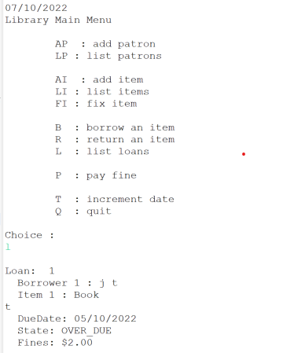

The item is returned:

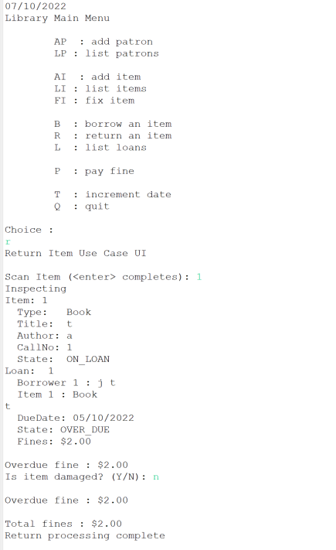

But when the patron comes to pay the fine:

The patron should only be charged $2.

Bug 2 – Loan limit is not enforced

Patron reaches loan limit in one session, but if they attempt to borrow again, they can borrow more items.

But then:

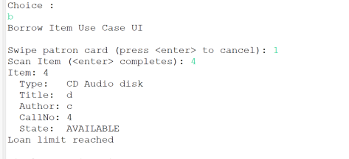

And

Resulting in:

The LOAN_LIMIT is 2, and patrons should not be able to borrow more items than this.